**Exercise 1: Control Structures**

**Initial table :**

**Loans**

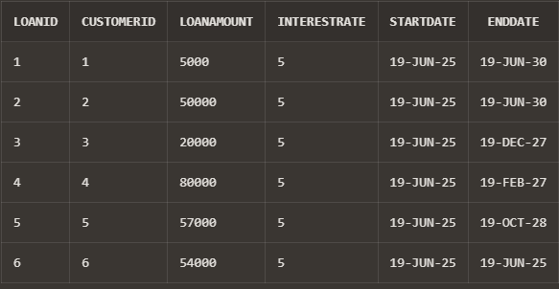

**Customers**

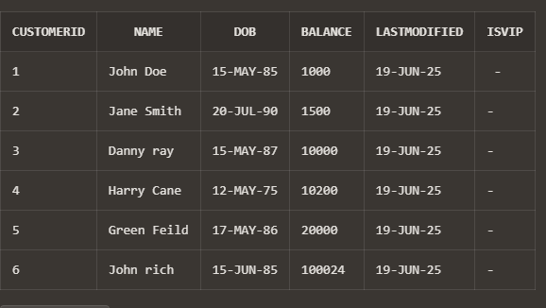

**Scenario 1:** The bank wants to apply a discount to loan interest rates for customers above 60 years old.

* + **Question:** Write a PL/SQL block that loops through all customers, checks their age, and if they are above 60, apply a 1% discount to their current loan interest rates.

BEGIN

FOR rec IN (

SELECT c.CustomerID, l.LoanID, l.InterestRate

FROM Customers c

JOIN Loans l ON c.CustomerID = l.CustomerID

WHERE MONTHS_BETWEEN(SYSDATE, c.DOB) / 12 > 60

) LOOP

UPDATE Loans

SET InterestRate = InterestRate - 1

WHERE LoanID = rec.LoanID;

END LOOP;

COMMIT;

END;



(No change in rate of interest since no one has an age of 60 or above.)

**Scenario 2:** A customer can be promoted to VIP status based on their balance.

* + **Question:** Write a PL/SQL block that iterates through all customers and sets a flag IsVIP to TRUE for those with a balance over $10,000.

ALTER TABLE Customers ADD (IsVIP CHAR(1));

BEGIN

FOR rec IN (

SELECT CustomerID, Balance

FROM Customers

WHERE Balance > 10000

) LOOP

UPDATE Customers

SET IsVIP = 'Y'

WHERE CustomerID = rec.CustomerID;

END LOOP;

COMMIT;

END;

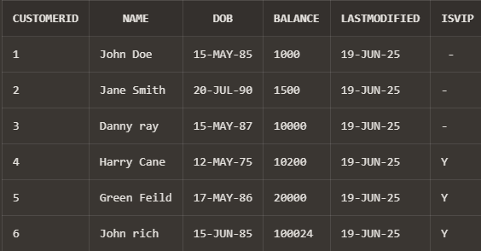

**Scenario 3:** The bank wants to send reminders to customers whose loans are due within the next 30 days.

* + **Question:** Write a PL/SQL block that fetches all loans due in the next 30 days and prints a reminder message for each customer.

BEGIN

FOR rec IN (

SELECT l.LoanID, c.Name, l.EndDate

FROM Loans l

JOIN Customers c ON l.CustomerID = c.CustomerID

WHERE l.EndDate BETWEEN SYSDATE-1 AND SYSDATE + 30

) LOOP

DBMS_OUTPUT.PUT_LINE('Reminder: Loan ID ' || rec.LoanID ||

' for customer ' || rec.Name ||

' is due on ' || TO_CHAR(rec.EndDate, 'DD-MON-YYYY'));

END LOOP;

END;

/

